SQL ASSESSMENT

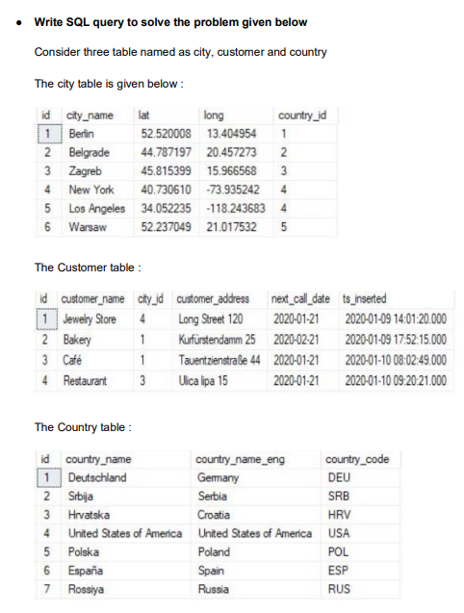

**Note :**

● While each city has a related country, not all countries have related cities (Spain & Russia don’t have them)

● Same stands for the customers. Each customer has the city_id value defined, but only 3 cities are being used (Berlin, Zagreb & New York)

**Task : 1**

(join multiple tables using left join) List all Countries and customers related to these countries.

For each country displaying its name in English, the name of the city customer is located in as well as the name of the customer.

Return even countries without related cities and customers.

Input:-

select c.countrynameeng,ct.cityname,cs.customername

from country c

left join city ct

on c.countryid= ct.countryid

left join customer cs

on ct.cityid=cs.cityid;

Output:-

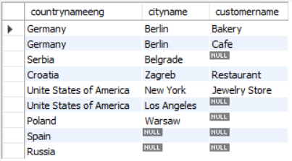

**Task : 2**

(join multiple tables using both left and inner join) Return the list of all countries that have pairs(exclude countries which are not referenced by any city).

For such pairs return all customers.

Return even pairs of not having a single customer.

Input:-

select c.countrynameeng,ct.cityname,cs.customername

from country c

join city ct

on c.countryid= ct.countryid

left join customer cs

on ct.cityid=cs.cityid;

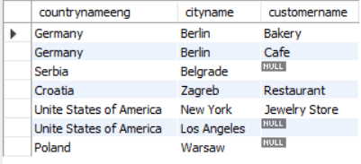Output:-